While connected to the Philips corporate network, open Internet Explorer and go to Internet Options/Connections/LAN settings. Set the Proxy server as shown:

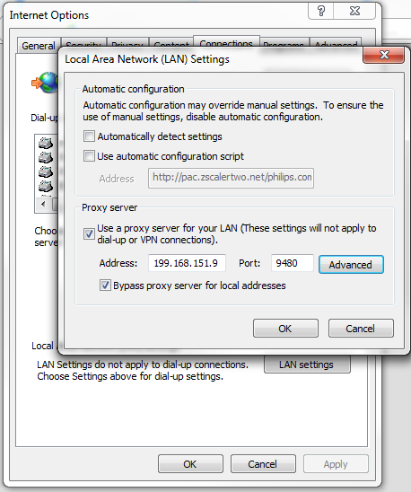

Click Advanced and add the Exception as shown.

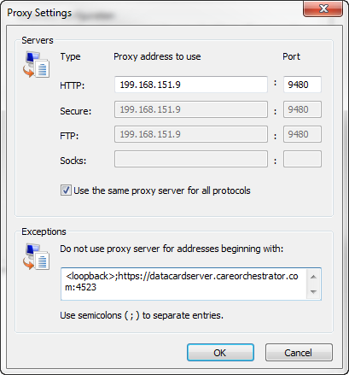

Save the IE settings.

Right click on the Data Card Server application in the system tray. Select the Proxy Settings option. Set the proxy server as shown:

Note: these settings do not connection to anything. The intention is to force the DCU to not be able to find its way out of the network on its own, so it must rely on the browser settings.

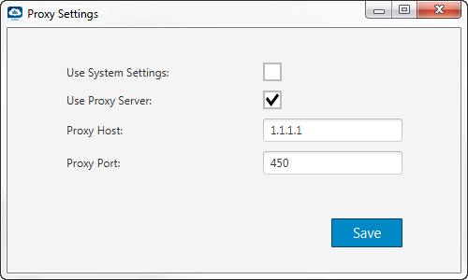

Save the DCU settings, then shut down and restart the DCU application and continue with testing.